Ana María León

Massachusetts Institute of Technology

**Grupo Austral (1939-1950)**

Grupo Austral was an architecture association of architects that operated mostly in Buenos Aires, Argentina from 1939 until approximately 1950. Catalan architect Antonio Bonet met Argentinians Juan Kurchan and Jorge Ferrari Hardoy while working at Le Corbusier’s office in Paris, 1936. The promising economic prospects of Argentina and the impending conflict in Europe prompted the group to move to Buenos Aires in 1938, where they founded Austral along with a core group of young local architects. Argentina had been going through a process of transformation and growth, and Austral sought to reframe this process with the planning ideas of Le Corbusier and the CIAM. The members of Austral teamed up in different configurations and worked at various scales, designing furniture, buildings, and urban plan proposals. However, although the Argentinian state was eager to embrace the technical and functional traits of modernity, it was also skeptical of foreign influences and mired in political conflicts. These conflicts ultimately prevented the realization of the urban plans the group instigated. Although short-lived, Austral productively collapsed different temporalities and geographies: between their formation in Le Corbusier’s office amidst the European avant-garde discourse, and their encounter with a rapidly modernizing Argentina.

In addition to Ferrari Hardoy, Kurchan, and Bonet, the founding members included architects Alberto Le Pera, Samuel Sanchez de Bustamante, Simón L. Ungar, Ricardo Vera Barros, Itala Fulvia Villa, and Hilario Zalba—but much of the group was in constant flux. Later additions included Eduardo Catalano, Carlos Coire, Jorge Vivanco, and Amancio Williams. The group was loosely modeled after the Spanish experience of the GATCPAC (a Catalan modern architecture group, which Bonet had been part of) and other CIAM-associated groups. They operated as a loose association in which various members met, collaborated in projects, conferences, contests, or exhibitions, and generally discussed architecture and urban planning topics.

The group’s ambition to publish a journal had to be reduced to the publication of three inserts in the Argentinian architecture journal *Nuestra Arquitectura* in 1939, which included their founding manifesto. Here Bonet, Ferrari Hardoy, and Kurchan denounced the stasis of modern architecture as obsessed with function, and proposed architecture could solve collective problems by understanding the psychology of the individual through the use of Surrealism. During their stay in Paris the leaders of Austral had been in touch with Chilean architect Roberto Matta Echaurren, who worked briefly at Le Corbusier’s atelier, teaming up with Bonet and likely influencing the young architects’ fascination with Surrealism. Shortly thereafter, Matta left architecture and became an artist, part of the Surrealist circle of Andre Breton. Back in Buenos Aires, the group’s affinity with Surrealism benefited from the popularity of Freudian psychoanalysis in 1940s Argentina. This cultural discourse provided the ideal ground for Austral to expand the usual modern rhetoric into the realm of the unconscious. In their writing, Austral often mentioned Catalan architect Antonio Gaudí and painters Picasso and Dalí as exemples of this search for the unconscious. Their projects referenced them indirectly, through the insertion of amorphous or surprising objects and a collage-like mix of glossy modern finishes and rough vernacular materials. For example, the BKF chair—named after its creators’ initials—combined the leather characteristic of the cattle-raising country with a modern metal skeleton.

Grupo Austral was eager to participate in the CIAM’s urban planning dialogue, and pursued several competitions and opportunities to design urban plans in western Argentina. They were not able to secure a commission, and as the country went further into political instability the group lost its focus. Some of them left—Catalano travelled to the United States, where he studies and later taught and practiced. Vivanco led a smaller group to the western city of Tucumán, where they founded the Institute of Architecture and Urbanism. The institute benefited from the presence of notable Italian architects and historians, including Bruno Zevi and Ernesto Rogers. Bonet moved to Uruguay and built a beach community in Punta Ballena.

The core group reunited in 1947, in a return to the Buenos Aires urban plan that Kurchan and Ferrari Hardoy had worked in at Le Corbusier’s office. The Swiss architect had intended to reawaken the possibility of an urban plan for Buenos Aires, first proposed in his 1929 visit. In 1948, the government of Juan Perón officially commissioned the group led by Ferrari Hardoy, but resisted including Le Corbusier, giving only vague promises to invite him as a consultant and at a later stage, to his great chagrin. The next year, a first stage of the plan was presented at CIAM 7, in Bergamo, Italy, by Bonet in representation of the group. Shortly afterwards, the unstable character of the Perón regime closed down the plan. In 1951, the work of several members of the group was included in Sigfried Giedion’s publication, *A Decade of New Architecture*. After a few more years of meeting as CIAM Argentina, the group dissolved, although the members kept working individually. Austral’s short but intense collaboration is an important hinge between early modernism and the architecture of the postwar. Their location away from the canonical centers of discourse gave them increased freedom to operate, but has also distanced them from modern narratives.

**List of works**

1939

BKF Chair (Antonio Bonet, Jorge Ferrari Hardoy, Juan Kurchan)

1939

Atelier de Artistas, Suipacha y Paraguay (Antonio Bonet, Horacio Vera Barros, Abel López Chas)

1941-2

Houses in Martínez (Antonio Bonet, Valerio Peluffo, Jorge Vivanco)

1941-3

Virrey del Pino Apartments (Jorge Ferrari Hardoy, Juan Kurchan)

1948-49

Buenos Aires Urban Plan, *Estudio del Plan de Buenos Aires*, EPBA (Antonio Bonet, Jorge Ferrari Hardoy, Jorge Vivanco, and others—not officially Austral but considered a “renaissance” of sorts)

**References and further reading**

Bonet, A., Ferrari Hardoy, J, and Kurchan, J., (1939) ‘Voluntad y Acción’, *Nuestra Arquitectura* 6.

Alvarez, F. (1996) *Antoni Bonet Castellana: 1913-1989*, Madrid: Ministerio de Fomento.

Giedion, S. (1951) *A Decade of New Architecture* (Zürich, Girsberger).

Liernur, J. (1999) ‘The Tree in the Box: Abstraction and Nature in the Virrey del Pino Apartments’, *Assemblage* 40: 26-35.

Liernur, J. (2008) *La red austral: obras y proyectos de Le Corbusier y sus discípulos en la Argentina (1924-1965)*, Buenos Aires: Universidad Nacional de Quilmes.

**Visual material:**

BKF Chair

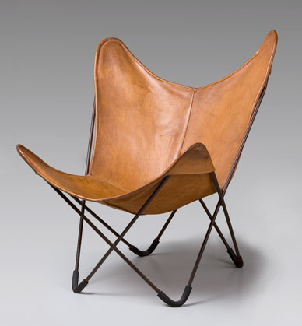

<http://commons.wikimedia.org/wiki/File:BKF_Chair.jpg>

Copyright: see link for details

Atelier de Artistas

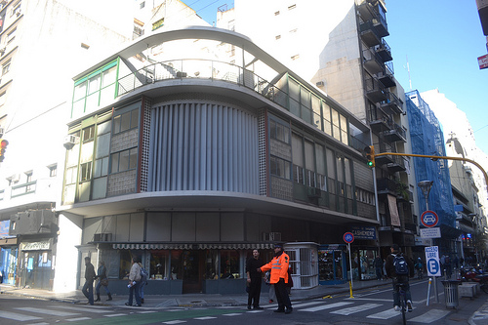

<http://www.flickr.com/photos/anamarialeon/6010108868/in/set-72157627358182496>

Copyright: Ana María León

Virrey del Pino

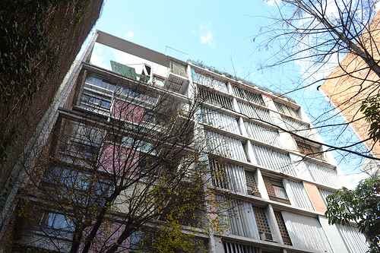

<http://www.flickr.com/photos/anamarialeon/6064113696/in/set-72157627358182496/>

Copyright: Ana María León